**SWE30009**

***Software Testing and Reliability***

**Assignment 2 Report**

**Student Name: Lau Ngoc Quyen**

**Student ID: 104198996**

**Task 1: Development of Fifth Test Cases For Sorting and Filtering Numbers**

**Test Case 1:  Only Even Numbers**

**Source Input (SI):** [2, 4 ,6 ,8 ,16 ,18 ,20]

**Testing Purposes:** This test case consists entirely of even integers. It tests the scenario where the output list of odd integers should be empty.

**Source Output (SO):  -** Odd numbers:  []  - Even numbers: [2, 4, 6, 8, 16, 18, 20]

**Metamorphic Relation (MR):**  Addition of a Constant to an Element

**Modification:** Add a constant value k to the first element of SI ( k = 22 )

**Follow-up Input (FI):** [2, 4 ,6 ,8 ,16 ,18 ,20, 22]

**Follow-up Ouput (FO):** **-** Odd numbers:  []  - Even numbers: [2, 4, 6, 8, 16, 18, 20, 22]

**Test Case 2:  Only Odd Numbers**

**Source Input (SI):** [1, 3, 5, 7, 9, 11, 15, 17]

**Testing Purposes:** This test case consists entirely of odd integers. It tests the scenario where the output list of even integers should be empty.

**Source Output (SO):  -** Odd numbers: [1, 3, 5, 7, 9, 11, 15, 17]  - Even numbers: []

**Metamorphic Relation (MR):** Permutation

**Modification:** Permute the elements of SI

**Follow-up Input (FI):** [3, 5, 7, 11, 17, 15, 1, 9]

**Follow-up Ouput (FO):** - Odd numbers: [1, 3, 5, 7, 9, 11, 15, 17] - Even numbers: [ ]

**Test Case 3:  Combination Of Odd and Even Numbers With Duplicates**

**Source Input (SI):** [1, 1, 2, 2, 3, 4, 4, 5, 5, 6, 7, 8, 9, 10, 11, 12, 13]

**Testing Purposes:** The test case involves dividing an output list of odd and even numbers, removing duplicates in ascending order, into odd and even numbers.

**Source Output (SO):  -** Odd numbers: [1, 3, 5, 7, 9, 11, 13]  - Even numbers: [2, 4, 6, 8, 10, 12]

**Metamorphic Relation (MR):** Duplication

**Modification:** Duplicate SI

**Follow-up Input (FI):** [2, 2, 2, 3, 4, 4, 5, 5, 5, 6, 7, 8, 9, 10, 11, 12, 13, 13]

**Follow-up Ouput (FO): -** Odd numbers: [ 3, 5, 7, 9, 11, 13] - Even numbers: [2, 4, 6, 8, 10, 12]

**Test Case 4: Large List With Mixed Number**

**Source Input (SI):** [15, 16 ,17, 18, 19, 20, 21, 22, 23, 24, 25, 26, 27, 28, 29, 30]

**Testing Purposes:** This test case contains a large number of mixed odd and even integers with duplicates. It tests the performance and correctness of the algorithm on larger inputs.

**Source Output (SO):** **-** Odd numbers: [17, 19, 21, 23, 25, 27, 29 ] - Even numbers: [18, 20, 22, 24, 26, 28, 30]

**Metamorphic Relation (MR):** Concatenation

**Modification:** Concatenate SI with itself

**Follow-up Input (FI):** [15, 15, 16, 16, 17, 17, 18, 18, 19, 20, 21, 22, 23, 24, 25, 26, 27, 28, 29, 30]

**Follow-up Ouput (FO): -** Odd numbers: [15, 17, 19, 21, 23, 25, 27, 29 ] - Even numbers: [16, 18, 20, 22, 24, 26, 28, 30]

**Test Case 5: Only One Odd Number**

**Source Input (SI):** [3]

**Testing Purposes:** This test case contains an single odd number

**Source Output (SO):** **-** Odd numbers: [3] - Even numbers: []

**Metamorphic Relation (MR):** Addition of a Constant to an Element

**Modification:** Add a constant value k to the first element of SI ( k = 2 )

**Follow-up Input (FI):** [3, 2]

**Follow-up Ouput (FO): -** Odd numbers: [3] - Even numbers: [2]

**Test Case 6: Only One Even Number**

**Source Input (SI):** [2]

**Testing Purposes:** This test case contains an single even number

**Source Output (SO):** **-** Odd numbers: [] - Even numbers: [2]

**Metamorphic Relation (MR):** Addition of a Constant to an Element

**Modification:** Add a constant value k to the first element of SI (k = 1)

**Follow-up Input (FI):** [1, 2]

**Follow-up Ouput (FO): -** Odd numbers: [1] - Even numbers: [2]

**Task 2: Selection Of Single Test Case**

**Selected Test Case:**

**Test Case 3:  Combination Of Odd and Even Numbers With Duplicates**

**Test Case:** [1, 1, 2, 2, 3, 4, 4, 5, 5, 6, 7, 8, 9, 10, 11, 12, 13]

**Expected Output:** - Odd numbers: [1, 3, 5, 7, 9, 11, 13] - Even numbers: [2, 4, 6, 8, 10, 12]

**Justification:**

* **Diverse Input:** Contains both odd and even numbers.
* **Duplicate Handling:** Includes duplicates (e.g., 1, 2, 3, 4, 5) to test removal.
* **Sorting Check:** Verifies sorting of both odd and even numbers.
* **Comprehensive Coverage:** Tests key functionalities—separation, duplication removal, and sorting.
* **Input Limitation:** 17 elements, well within the 20-element limit, ensuring adequate performance testing.

=> This test case effectively evaluates the core features of the program with limited testing resources.

**Task 3: Testing, Analysis And Suggestion For Improving of the Program**

**Test Case 1:  Only Even Numbers**

**Test Case:** [2, 4 ,6 ,8 ,16 ,18 ,20]

**Actual Result:** - Odd numbers:  [] - Even numbers: [2, 4, 6, 8, 16, 18, 20]

**Test Case 2:  Only Odd Numbers**

**Test Case:** [1, 3, 5, 7, 9, 11, 15, 17]

**Actual Result:**- Odd numbers: [1, 3, 5, 7, 9, 11, 15, 17] - Even numbers: [ ]

**Test Case 3:  Combination Of Odd and Even Numbers With Duplicates**

**Test Case:** [1, 1, 2, 2, 3, 4, 4, 5, 5, 6, 7, 8, 9, 10, 11, 12, 13] ( Error Program )

**Actual Result:** - Odd numbers: [1, 1, 3, 5, 5, 7, 9, 11, 13] -Even numbers: [2, 2, 4, 4, 6, 8, 10, 12]

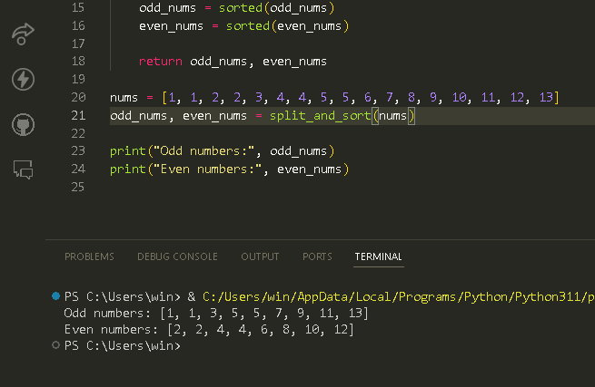

**Test Case 4: Large List With Mixed Number**

**Test Case:** [15, 16 ,17, 18, 19, 20, 21, 22, 23, 24, 25, 26, 27, 28, 29, 30]

**Actual Result:** - “Terminal Error “  ( Error Program )

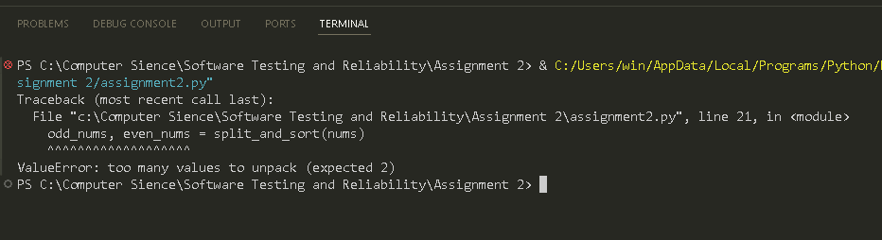

**Test Case 5: Only One Odd Number**

**Test Case:** [3]

**Actual Result:** Odd numbers: [3]

**Test Case 6: Only One Even Number**

**Test Case:** [2]

**Actual Result:** Even numbers: [2]

**Discussions And Insights:**

* **Correctness:** Althoughthe function split_and_sort(nums) correctly handles valid input cases by splitting the list into odd and even numbers, it sorts the lists in ascending order. It does not remove all the odd and even duplicates.
* **Error Handling**:  The function unsuccessfully detects and handles errors for inputs lists with more than 20 elements which lead to the terminal error in the text editor

**Suggestion For Program Improvement:**

1. **Using set()**

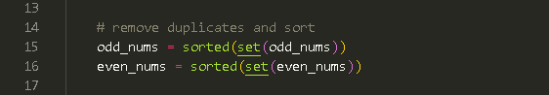

* The set() function converts lists of numbers into sets, removing duplicates, ensuring unique values in odd_nums and even_nums lists. The sorted() function sorts elements in ascending order, meeting problem statement requirements.

1. **Using the if() and else() statements**

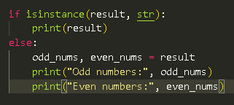

* The split_and_sort() function returns either a string or a tuple containing odd_nums and even_nums lists, depending on whether the function was successful or not. The if-else statement handles both cases, ensuring the user receives the appropriate output.

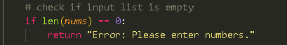

* Len(nums) evaluates whether the length of the input list nums is zero, meaning the list has no elements and it will return an error for an empty input .

1. **Loop through the indices of the list using for() condition**

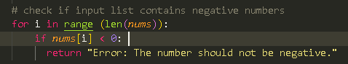

* This check iterates over each element in the input list nums to see if there are any negative numbers loops through the indices of the list. This check iterates over each element in the input list nums to see if there are any negative numbers.

***Link to code****:* [*https://github.com/quynezz/SWE30009*](https://github.com/quynezz/SWE30009)